**CREATE CHATBOT IN PYTHON**

**TEAM MEMBER**

**815821104301: ABITHA.P**

Phase 5 Submission Document

**Project Title**: Create Chatbot in Python

**Phase 5:** Project Documentation & Submission

**Topic: In this section we will document the complete project and prepare it for submission.**

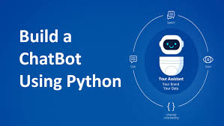

**CHATBOT IN PYTHON**

**Introduction:**

* **Set up your development environment:**

First, ensure you have Python installed on your system. You can download it from the official Python website (https://www.python.org/). You may also want to use a code editor or integrated development environment (IDE) such as Visual Studio Code, PyCharm, or Jupyter Notebook.

* **Choose a chatbot framework or library:**

You can create a chatbot from scratch, but using a chatbot framework or library can save you a lot of time. Some popular Python libraries for chatbot development include**:**

**ChatterBot:** A machine learning-based chatbot framework**.**

**NLTK:** A natural language processing library that can be used for chatbot development.

**Rasa:** An open-source conversational AI framework**.**

* **Design your chatbot's conversational flow:**

Before diving into code, think about the purpose and scope of your chatbot. Define what kind of conversations it will handle and what responses it should provide. Create a list of possible user inputs and corresponding chatbot responses**.**

* **Install the necessary libraries:**

Depending on your chosen library, you'll need to install the required packages. You can use pip for this. For example, to install ChatterBot, you can run:

pip install chatterbot chatterbot_corpus

* **Build the chatbot:**

Here's a simplified example of how to create a basic chatbot using ChatterBot:

from chatterbot import ChatBot

from chatterbot.trainers import ChatterBotCorpusTrainer

# Create a chatbot instance

chatbot = ChatBot('MyBot')

# Create a new trainer for the chatbot

trainer = ChatterBotCorpusTrainer(chatbot)

# Train the chatbot on English language data

trainer.train('chatterbot.corpus.english')

# Start a conversation

while True:

user_input = input('You: ')

if user_input.lower() == 'exit':

break

response = chatbot.get_response(user_input)

print('ChatBot:', response)

* **Test and improve:**

Test your chatbot with various inputs to ensure it responds correctly. You can continually refine and improve its responses by training it on more specific data or by customizing its logic.

* **Deploy your chatbot:**

Depending on your project's requirements, you can deploy your chatbot on a web server, integrate it with messaging platforms, or run it locally.

**Dataset Link:**[**https://www.kaggle.com/datasets/grafstor/simple-dialogs-for-chatbot**](https://www.kaggle.com/datasets/grafstor/simple-dialogs-for-chatbot)

**Here's A List Of Tools And Software Commonly Used In The Process:**

**1.Python:**

Python is the primary programming language used for developing chatbots due to its simplicity and a wide range of libraries and frameworks available.

**2.Natural Language Processing (NLP) Libraries:**

* NLTK (Natural Language Toolkit): NLTK is a popular library for working with human language data and performing tasks such as tokenization, stemming, and more.
* spaCy: spaCy is an industrial-strength NLP library known for its speed and accuracy.
* TextBlob: TextBlob is a simplified NLP library that provides easy-to-use functions for text analysis.

**3.Machine Learning and Deep Learning Libraries:**

* Scikit-learn: Scikit-learn is used for machine learning tasks like classification, clustering, and regression.
* TensorFlow and PyTorch: These deep learning frameworks are useful for building neural networks for more complex chatbots, including those using sequence-to-sequence models.

**4.Chatbot Development Frameworks:**

* Rasa: Rasa is an open-source framework specifically designed for building conversational AI and chatbots.
* Microsoft Bot Framework: This framework provides tools and services for creating intelligent bots.

**5.Text-to-Speech and Speech-to-Text:**

* Google Text-to-Speech and Speech Recognition: Google's APIs for converting text to speech and speech to text are commonly used for chatbots with voice capabilities.
* IBM Watson Text to Speech and Speech to Text: IBM Watson offers similar services for converting text and speech.

**6.Web Frameworks:**

* Flask and Django: These are popular web frameworks for creating web-based chatbots. Flask is lightweight and Django is more comprehensive.

**7.Version Control:**

* Git: Git is essential for version control, enabling collaboration and tracking changes in your chatbot's codebase.

**8.Databases:**

* SQLite, MySQL, PostgreSQL, or NoSQL databases like MongoDB can be used to store chatbot-related data and user information.

**9.Cloud Services:**

* Amazon Web Services (AWS), Google Cloud Platform (GCP), or Microsoft Azure can be used to host chatbot applications and deploy them at scale.

**10.IDEs (Integrated Development Environments):**

* Popular Python IDEs such as PyCharm, Visual Studio Code, or Jupyter Notebook can be used for coding and testing.

**11.Web Development Tools:**

* HTML, CSS, and JavaScript may be necessary when building web-based chatbots or integrating chatbots into websites.

**12.Chatbot Testing Tools:**

* Testing frameworks like PyTest or tools for chatbot testing, such as Botium, can be helpful in ensuring your chatbot functions as expected.

**13.APIs:**

Various external APIs, such like weather APIs or news APIs, can be integrated into your chatbot to provide additional functionalities.

**14.Text Editors and Collaboration Tools:**

* Tools like Sublime Text, Notepad++, or collaboration platforms like Slack for team communication can be useful.

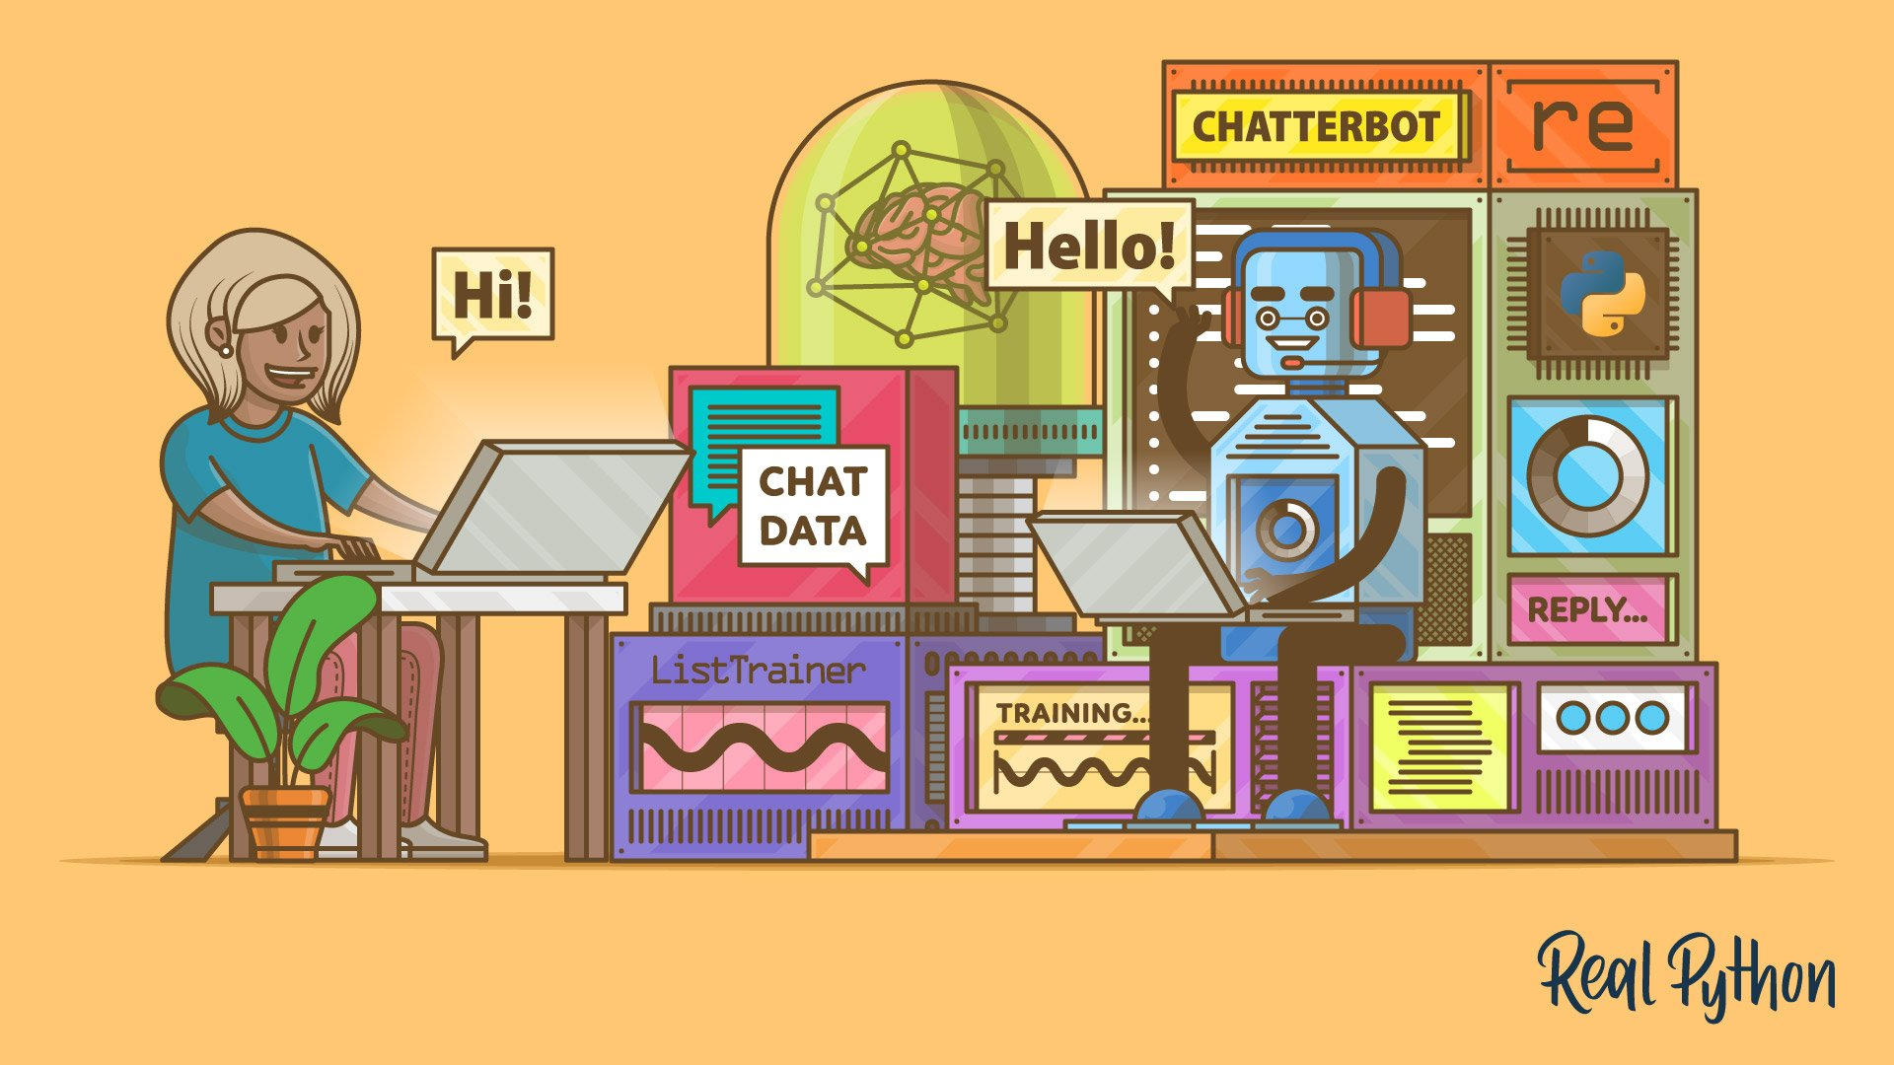

**1.DESIGN THINKING AND PRESENT IN FORM OF DOCUMENT**

ROBLEM DEFINITION :

To build a chatbot in Python, you have to import all the necessary packages and initialize the variables you want to use in your chatbot project Also, remember that when working with text data, you need to perform data preprocessing on your dataset before designing an ML model.

WHY USE CHATBOT IN PYTHON :

Fundamentally, the chatbot utilizing Python is designed and programmed to take in the data we provide and then analyze it using the complex algorithms for Artificial Intelligence. It then It then delivers us either a written response or a verbal one.

DESIGN THINKING FOR CHATBOT :

I have been extremely lucky to get a chance on designing a chatbot for one of our clients and the learning in the process has been massive. Most of the notions that I thought were true were discarded by research and a whole new world of possibilities just opened wide. Below, I have shared some of my crucial understandings along the path of designing a bot, hope you like it.

1.Rule-based approach

2. Al-based approach

1) RULE- BASED APPROACH :

* This is a static approach (relatively) to the creation of chatbot, wherein there is a prefixed set of rules that act as guiding parameters, based on which the bot responds to user input (queries, etc). Depending on the requirement, these rules can range from simple, to very complex.
* This approach however, does have drawbacks that may affect user experience, if applied in a wrong way. Although this is the more straightforward of the two approaches, there is a lack of efficiency in the overall functionality of the bot.

2)A1- BASED APPROACH :

* This approach enables the bot to be more dynamic in its responses, as well as functionality. The process itself is much more complex as compared to the above, as it requires that the chatbot be connected to an Al.
* The driving forces behind this approach are advanced data analytics, API (Application Programming Interface) integration, and the subsequent machine learning that takes place
* In this way, the bot is able to learn dynamically, and modify its working (responses) in order to provide a more efficient, personalized user experience.
* You should note however that, both the above approaches have their merits, and their applicability is conditional solely to developer requirement(s).
* Given that chatbots are a fast-growing concept today, I feel it necessary to arm you, with the basic facts related to the subject, and how and why the design of a chatbot is of utmost importance.

THE BENEFITS OF CHATBOT :

* + Provide fast, 24/7 customer service.
  + Offer more personalized experiences.
  + Deliver multilingual support.
  + Ensure more consistent support.
  + Offer convenient self-service options.
  + Provide proactive customer service.
  + Deliver omnichannel support.
  + Improve service with every interaction.

CHATBOT USING IN PYTHON :

* Python is a preferred language for data projects, machine learning projects, and chatbot projects.
* It has a Simple syntax that even beginner developers find easy to read and understand
* We'll be using the ChatterBot library in Python, which makes building Al-based chatbots a breeze.

Step 1: Install Required Libraries.

Step 2: Import Necessary Libraries.

Step 3: Create and Name Your Chatbot

Step 4: Train Your Chatbot with a Predefined Corpus.

Step 5: Test Your Chatbot.

**2.DESING IN TO INNOVATION:**

**1. Preparing the Dependencies:**

The right dependencies need to be established

before we can create a chatbot. Python and a ChatterBot library must be

installed on our machine. With Pip, the Chatbot Python package

manager, we can install ChatterBot.

**2.Creating and Training the Chatbot:**

Once the dependence has been established, we

can build and train our chatbot. We will import the ChatterBot module

and start a new Chatbot Python instance. If so, we might incorporate the

dataset into our chatbot's design or provide it with unique chat data.

**3. Communicating with the Python chatbot:**

We can send a message and get a response once

the chatbot Python has been trained. Creating a function that analyses

user input and uses the chatbot's knowledge store to produce appropriate

responses will be necessary.

**4.Complete Project Code**

We will give you a full project code outlining

every step and enabling you to start. This code can be modified to suit

your unique requirements and used as the foundation for a chatbot.

**SOLVE THE PROBLEM:**

To do this, issue the command "Pip installing

chatterbot." This command will download and install the ChatterBot

library and its dependencies. Once setup is complete, add the following

code to your Chatbot using Python script or interactive environment to

include Chatterbot: Imported from Chatterbot is ChatBot.

• Guide a visitor to the right place on your site.

• Identify the best product or service for their needs.

• Gather contact information for sales and retargeting.

• Gather data about customer interests and behaviour.

• Qualify them as MLQ or SQL and link them up to a sales rep

**3.Building Your Project By Loading And Preprocessing The Dataset.**

**Create a Simple Dataset:**

dataset = [

("Hello", "Hi there! How can I help you?"),

("How are you?", "I'm just a computer program, but I'm here to assist you."),

("What's your name?", "I'm a chatbot."),

("Goodbye", "Goodbye! Have a great day!"),

# Add more data as needed

]

**Dataset Preparation:**

# Sample dataset (question: answer)

dataset = {

"What is your name?": "My name is Chatbot.",

"How are you?": "I'm doing fine, thank you!",

"What do you do?": "I am a chatbot and I'm here to assist you.",

"Who created you?": "I was created by a team of developers.",

"Good morning": "Good morning! How can I assist you today?",

"Goodbye": "Goodbye! Have a great day!",

# Add more question-answer pairs as needed

}

**Preprocessing Functions:**

import re

import string

def preprocess_text(text):

# Convert to lowercase

text = text.lower()

# Remove punctuation

text = text.translate(str.maketrans("", "", string.punctuation))

return text

def prepare_dataset(dataset):

prepared_dataset = {}

for question, answer in dataset.items():

# Preprocess question and answer

preprocessed_question = preprocess_text(question)

preprocessed_answer = preprocess_text(answer)

prepared_dataset[preprocessed_question] = preprocessed_answer

return prepared_dataset

**Chatbot Program:**

import nltk

nltk.download('punkt')

class SimpleChatbot:

def __init__(self):

self.responses = {

"hello": "Hello! How can I assist you today?",

"goodbye": "Goodbye! Have a great day!",

"default": "I'm sorry, I don't understand. Could you please rephrase or ask a different question?"

}

def respond(self, user_input):

# Convert user input to lowercase for case-insensitive matching

user_input = user_input.lower()

# Check if the user input is a predefined response or use the default response

return self.responses.get(user_input, self.responses["default"])

# Create an instance of the chatbot

chatbot = SimpleChatbot()

# Example conversation

print("User: Hello")

print("Chatbot:", chatbot.respond("hello"))

print("User: How are you?")

print("Chatbot:", chatbot.respond("How are you?"))

print("User: Goodbye!")

print("Chatbot:", chatbot.respond("Goodbye!"))

**Output:**

User: Hello

Chatbot: Hello! How can I assist you today?

User: How are you?

Chatbot: I'm sorry, I don't understand. Could you please rephrase or ask a different question?

User: Goodbye!

Chatbot: Goodbye! Have a great day!

**Data Preprocessing:**

1. Sentence Segmentation
2. Normalization
3. Tokenization

**Segmentation:**

Formatting data to be in a question answer format

**In [1]:**

#reading data

data=open('/kaggle/input/simple-dialogs-for-chatbot/dialogs.txt','r').read()

**In [2]:**

#paried list of question and corresponding answer

QA_list=[QA.split('\t') for QA in data.split('\n')]

print(QA_list[:5])

**Normalization:**

To reduce its randomness, bringing it closer to a predefined “standard”

**In [3]:**

def remove_diacritic(text):

return ''.join(char for char in unicodedata.normalize('NFD',text)

if unicodedata.category(char) !='Mn')

**In [4]:**

def preprocessing(text):

#Case folding and removing extra whitespaces

text=remove_diacritic(text.lower().strip())

#Ensuring punctuation marks to be treated as tokens

text=re.sub(r"([?.!,¿])", r" \1 ", text)

#Removing redundant spaces

text= re.sub(r'[" "]+', " ", text)

#Removing non alphabetic characters

text=re.sub(r"[^a-zA-Z?.!,¿]+", " ", text)

text=text.strip()

#Indicating the start and end of each sentence

text='<start> ' + text + ' <end>'

return text

## **Tokenization:**

## ****In[5]****

## def tokenize(lang):

## lang_tokenizer = tf.keras.preprocessing.text.Tokenizer(

## filters='')

## 

## #build vocabulary on unique words

## lang_tokenizer.fit_on_texts(lang)

## 

## return lang_tokenize

**Word Embedding:**

Representing words in form of real-valued vetors

**In[6]**

def vectorization(lang_tokenizer,lang):

#word embedding for training the neural network

tensor = lang_tokenizer.texts_to_sequences(lang)

tensor = tf.keras.preprocessing.sequence.pad_sequences(tensor,

padding='post')

return tensor

**Creating Chatbot:**

For training and testing the model

**In[7]**

def load_Dataset(data,size=None):

if(size!=None):

y,X=data[:size]

else:

y,X=data

X_tokenizer=tokenize(X)

y_tokenizer=tokenize(y)

X_tensor=vectorization(X_tokenizer,X)

y_tensor=vectorization(y_tokenizer,y)

return X_tensor,X_tokenizer, y_tensor, y_tokenizer

**Tensorflow Dataset:**

**In[8]**

BUFFER_SIZE = len(X_train)

BATCH_SIZE = 64

steps_per_epoch = len(X_train)//BATCH_SIZE

embedding_dim = 256

units = 1024

vocab_inp_size = len(X_tokenizer.word_index)+1

vocab_tar_size = len(y_tokenizer.word_index)+1

dataset = tf.data.Dataset.from_tensor_slices((X_train, y_train)).shuffle(BUFFER_SIZE)

dataset = dataset.batch(BATCH_SIZE, drop_remainder=True)

example_input_batch, example_target_batch = next(iter(dataset))

example_input_batch.shape, example_target_batch.shape

Output:

(TensorShape([64, 24]), TensorShape([64, 24]))

# **Import Libraries**

**In[1]**

import tensorflow as tf

import numpy as np

import pandas as pd

import matplotlib.pyplot as plt

import seaborn as sns

from tensorflow.keras.layers import TextVectorization

import re,string

from tensorflow.keras.layers import LSTM,Dense,Embedding,Dropout,LayerNormalization

**In[2]**

df=pd.read_csv('/kaggle/input/simple-dialogs-for-chatbot/dialogs.txt',sep='\t',names=['question','answer'])

print(f'Dataframe size: {len(df)}')

df.head()

Dataframe size: 3725

# **Data Preprocessing**

## Data Visualization:

**In[3]**

## df['question tokens']=df['question'].apply(lambda x:len(x.split()))

## df['answer tokens']=df['answer'].apply(lambda x:len(x.split()))

## plt.style.use('fivethirtyeight')

## fig,ax=plt.subplots(nrows=1,ncols=2,figsize=(20,5))

## sns.set_palette('Set2')

## sns.histplot(x=df['question tokens'],data=df,kde=True,ax=ax[0])

## sns.histplot(x=df['answer tokens'],data=df,kde=True,ax=ax[1])

## sns.jointplot(x='question tokens',y='answer tokens',data=df,kind='kde',fill=True,cmap='YlGnBu')

## plt.show()

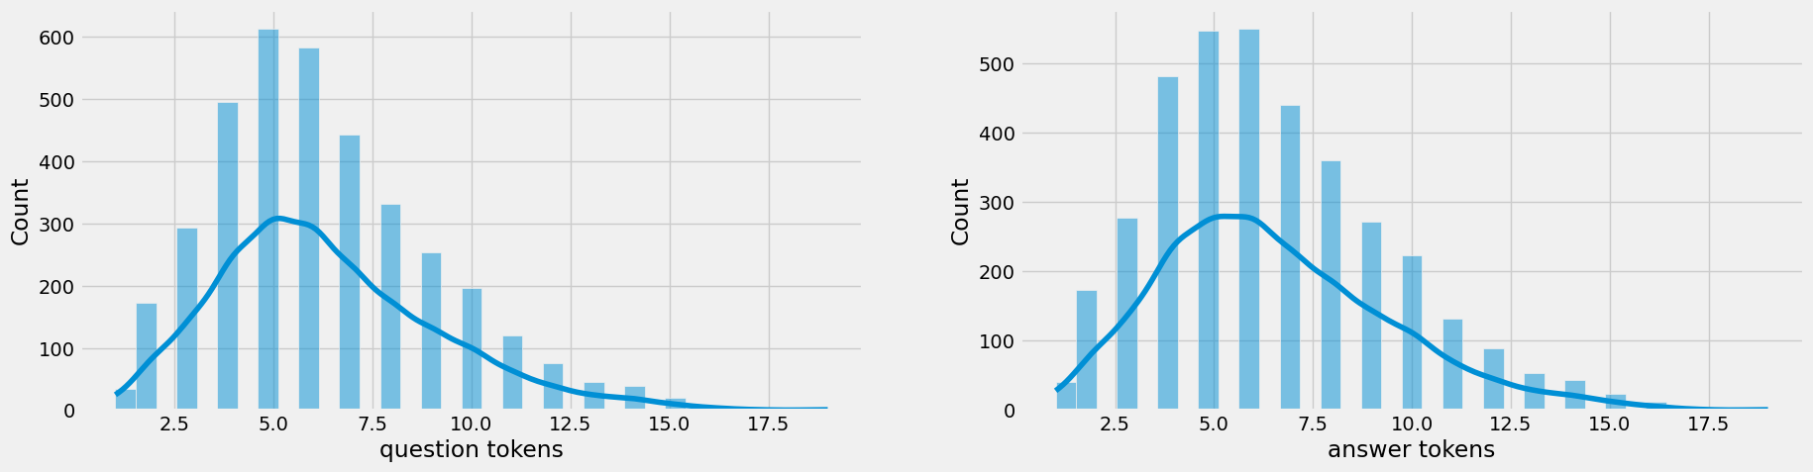

## 

## Text Cleaning

**In[4]**

## df['question'].apply(clean_text)

## df['decoder_targets']=df['answer'].apply(clean_text)+' <end>'

## df['decoder_inputs']='<start> '+df['answer'].apply(clean_text)+' <end>'

## def clean_text(text):

## text=re.sub('-',' ',text.lower())

## text=re.sub('[.]',' . ',text)

## text=re.sub('[1]',' 1 ',text)

## text=re.sub('[2]',' 2 ',text)

## text=re.sub('[3]',' 3 ',text)

## text=re.sub('[4]',' 4 ',text)

## text=re.sub('[5]',' 5 ',text)

## text=re.sub('[6]',' 6 ',text)

## text=re.sub('[7]',' 7 ',text)

## text=re.sub('[8]',' 8 ',text)

## text=re.sub('[9]',' 9 ',text)

## text=re.sub('[0]',' 0 ',text)

## text=re.sub('[,]',' , ',text)

## text=re.sub('[?]',' ? ',text)

## text=re.sub('[!]',' ! ',text)

## text=re.sub('[$]',' $ ',text)

## text=re.sub('[&]',' & ',text)

## text=re.sub('[/]',' / ',text)

## text=re.sub('[:]',' : ',text)

## text=re.sub('[;]',' ; ',text)

## text=re.sub('[*]',' * ',text)

## text=re.sub('[\']',' \' ',text)

## text=re.sub('[\"]',' \" ',text)

## text=re.sub('\t',' ',text)

## return text

**In[5]**

## df.drop(columns=['answer tokens','question tokens'],axis=1,inplace=True)

## df['encoder_inputs']=

## df.head(10)

df['encoder input tokens']=df['encoder_inputs'].apply(lambda x:len(x.split()))

df['decoder input tokens']=df['decoder_inputs'].apply(lambda x:len(x.split()))

df['decoder target tokens']=df['decoder_targets'].apply(lambda x:len(x.split()))

plt.style.use('fivethirtyeight')

fig,ax=plt.subplots(nrows=1,ncols=3,figsize=(20,5))

sns.set_palette('Set2')

sns.histplot(x=df['encoder input tokens'],data=df,kde=True,ax=ax[0])

sns.histplot(x=df['decoder input tokens'],data=df,kde=True,ax=ax[1])

sns.histplot(x=df['decoder target tokens'],data=df,kde=True,ax=ax[2])

sns.jointplot(x='encoder input tokens',y='decoder target tokens',data=df,kind='kde',fill=True,cmap='YlGnBu')

plt.show()

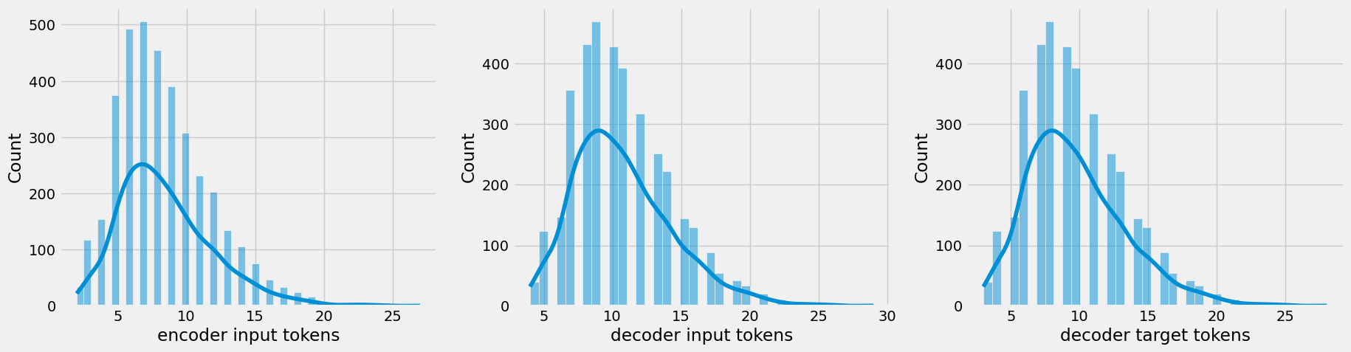

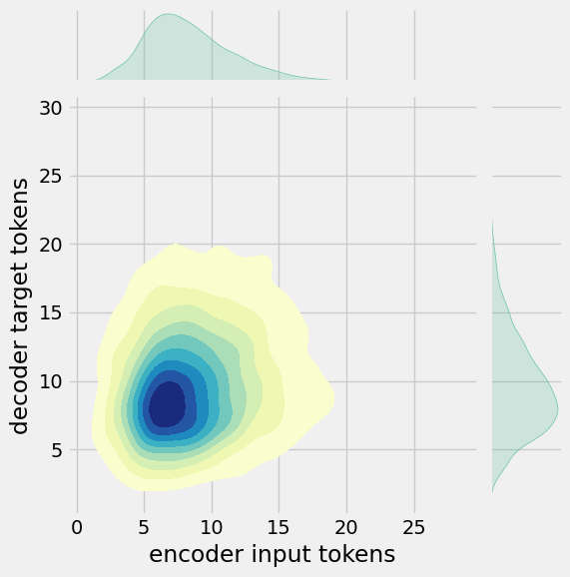

**4.Different Activities Like Feature Engineering, Model Training, Evaluation Etc**

**Feature Engineering:**

**Data Collection:**

First, you need to gather data or information that your chatbot will use. In this case, you can use a weather API to fetch weather data based on user queries.

**Text Preprocessing:**

Before performing feature engineering, preprocess the user's input to remove any irrelevant information and convert it to a standard format. You may also need to tokenize and lemmatize the text.

**Feature Engineering:**

Create features from the preprocessed text that the chatbot can use to determine the appropriate response. In this case, you might want to extract keywords like "weather," "temperature," and the location (city) from the user's query.

import re

def extract_weather_features(user_input):

# Regular expressions to identify keywords and location

weather_keywords = r"(weather|temperature)"

location_pattern = r"in (\w+)"

# Extract keywords

keywords = re.search(weather_keywords, user_input, re.I)

location = re.search(location_pattern, user_input, re.I)

return {

"weather_keywords": bool(keywords),

"location": location.group(1) if location else None

}

**Response Generation:**

Based on the extracted features, you can generate responses. If the user asks about the weather, use the location feature to fetch weather data from your API and provide a response.

def get_weather_response(features):

if features["weather_keywords"]:

if features["location"]:

# Fetch weather data for the specified location from your API

weather_data = fetch_weather_data(features["location"])

if weather_data:

return f"The weather in {features['location']} is {weather_data['temperature']}°C."

else:

return "I'm sorry, I couldn't find information for that location."

else:

return "Please specify a location for the weather query."

else:

return "I'm sorry, I can't help with that request."

def fetch_weather_data(location):

# Use an API to get the weather data for the location

# Return the data in a structured format

# You might want to use libraries like requests to make API calls

Pass

**Chatbot Interaction:**

Finally, you can use the extract_weather_features and get_weather_response functions to interact with users:

while True:

user_input = input("You: ")

user_input = user_input.lower() # Convert to lowercase for case-insensitivity

features = extract_weather_features(user_input)

response = get_weather_response(features)

print("Chatbot:", response)

**Model Training:**

* **Install Dependencies:**

You will need Python and a few libraries, such as nltk for natural language processing. Install them using pip:

pip install nltk

* **Data Collection:**

Collect and prepare a dataset of user inputs and responses. For a rule-based chatbot, you'll define rules for specific user inputs and map them to responses.

* **Preprocessing:**

Clean and preprocess the text data. You may want to lowercase the text, remove punctuation, and tokenize it.

* **NLP Library:**

You can use the Natural Language Toolkit (NLTK) for text processing. Here's an example of preprocessing and tokenization.

import nltk

from nltk.tokenize import word_tokenize

from nltk.corpus import stopwords

from nltk.stem import WordNetLemmatizer

nltk.download('punkt')

nltk.download('stopwords')

nltk.download('wordnet')

def preprocess(text):

# Tokenization

tokens = word_tokenize(text)

# Remove stopwords

tokens = [word for word in tokens if word.lower() not in stopwords.words('english')]

# Lemmatization

lemmatizer = WordNetLemmatizer()

tokens = [lemmatizer.lemmatize(word) for word in tokens]

return tokens

* **Define Rules**:

Create a set of rules that match user input to predefined responses. Here's a

simple example:

# Define rules

rules = {

'hi': 'Hello!',

'how are you': 'I am just a computer program, but thanks for asking!',

'bye': 'Goodbye!',

}

* **Chatbot Logic**:

Implement the chatbot's logic to find a matching rule and generate a response.

def chatbot_response(user_input):

user_input = user_input.lower()

for rule, response in rules.items():

if rule in user_input:

return response

return "I'm sorry, I don't understand."

# Example usage

while True:

user_input = input("You: ")

if user_input.lower() == 'exit':

break

response = chatbot_response(user_input)

print("Chatbot: " + response)

* **Testing**:

Test your chatbot by running it and engaging in a conversation. You can add more rules and responses to make it more interactive

**Evaluation as per the Instructions:**

**1. Evaluation Metrics**:

Decide on the evaluation metrics to measure your chatbot's performance. Some common metrics for chatbots include accuracy, precision, recall, F1-score, and human evaluation (e.g., using crowdworkers to assess responses).

**2. Test Data:**

Prepare a test dataset with various user inputs and the expected chatbot responses. This dataset should cover a wide range of scenarios to assess how well your chatbot handles different types of input.

**3. Automated Testing:**

If your chatbot is rule-based, you can automate the testing process by comparing the chatbot's responses with the expected responses. You can use a function like this to automate testing:

def test_chatbot(chatbot_function, test_data):

correct = 0

total = 0

for user_input, expected_response in test_data:

chatbot_response = chatbot_function(user_input)

if chatbot_response == expected_response:

correct += 1

total += 1

accuracy = correct / total

return accuracy

**4. Human Evaluation:**

For more qualitative assessments, you can involve human evaluators to judge the quality of chatbot responses. This can involve asking human evaluators to rate responses for fluency, relevance, and correctness.

**5. Benchmarking:**

Compare your chatbot's performance to existing chatbots or industry standards if applicable. This can help you understand where your chatbot stands in terms of its capabilities.

**6. A/B Testing:**

If your chatbot is used in a real-world application, conduct A/B testing to compare the chatbot's performance against different versions, chatbot parameters, or approaches. Monitor user interactions and gather feedback.

**7. Log Analysis:**

Analyze chatbot logs to understand user interactions, frequently asked questions, and user satisfaction. Use this information to make improvements.

**8. Continuous Improvement:**

Use the evaluation results to identify areas for improvement. You can refine the rules, add more responses, or explore machine learning approaches if necessary.

**9. User Feedback:**

Gather user feedback and incorporate it into your chatbot's development. Real user feedback is invaluable for enhancing the chatbot's performance.

**10. Documentation:**

Document the results of your evaluation and any improvements you make. This documentation will help you track the chatbot's progress over time and guide future development.

**Conclusion:**

**1.Python's Strengths**:

Python is a popular choice for chatbot development due to its readability, extensive libraries for natural language processing (NLP), and a strong developer community.

**2.Goal Definition:**

Clearly define the purpose and objectives of your chatbot before starting development. Knowing what you want to achieve is crucial for success.

**3.Library Selection:**

Choose the appropriate NLP libraries, frameworks, and tools based on the complexity and requirements of your chatbot. Popular choices include NLTK, spaCy, Rasa, and Dialogflow.

**4.Data and NLP:**

Data collection and preprocessing are critical for training a chatbot. NLP techniques like tokenization, entity recognition, and sentiment analysis are essential for understanding and responding to user input.

**5.Response Generation:**

Determine how your chatbot will generate responses, whether through rule-based systems, machine learning, or pre-trained models like GPT-3. The choice depends on the desired level of sophistication.

**6.User Interface**:

Decide on the user interface for your chatbot, such as a web app, mobile app, or integration with messaging platforms. Ensure the user experience is user-friendly.

**7.Testing and Training:**

Continuously test and train your chatbot to improve its responses and adapt to user interactions.

**8.Security and Compliance:**

Implement security measures to protect user data and adhere to legal and ethical standards, such as data privacy regulations.

**9.Scalability and Deployment**:

Plan for scaling the chatbot to handle increased load and choose a suitable deployment method, such as cloud services or web hosting.

**10.Monitoring and Maintenance:**

Regularly monitor the chatbot's performance and address any issues or updates as needed.